Create and Configure Jenkins Jobs with Job Sequencing

Logging into Jenkins before job creation:
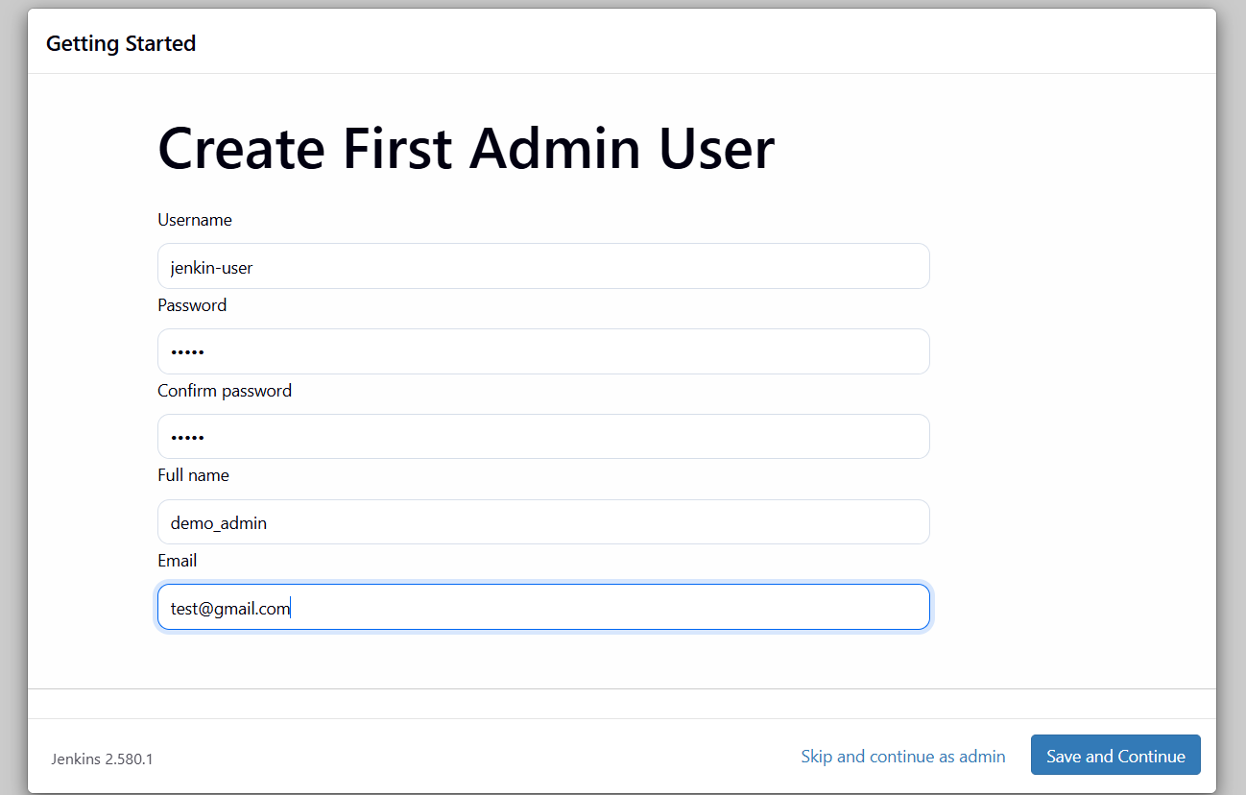

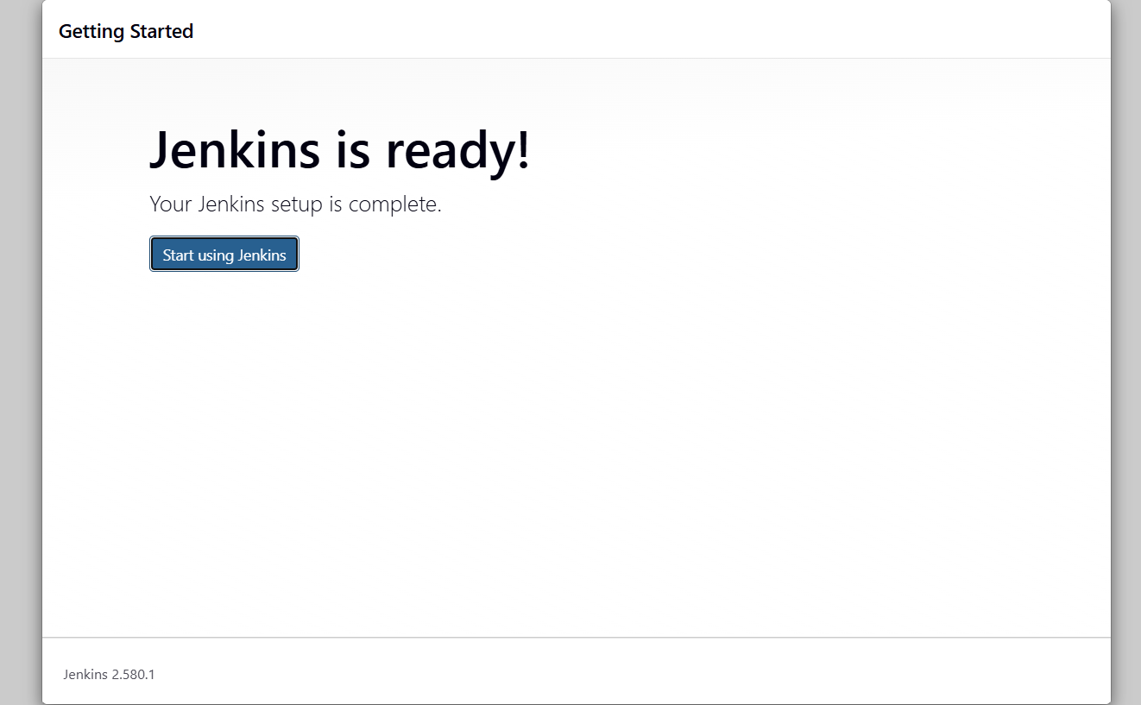
JOB Creation(build job, test job, deploy job)
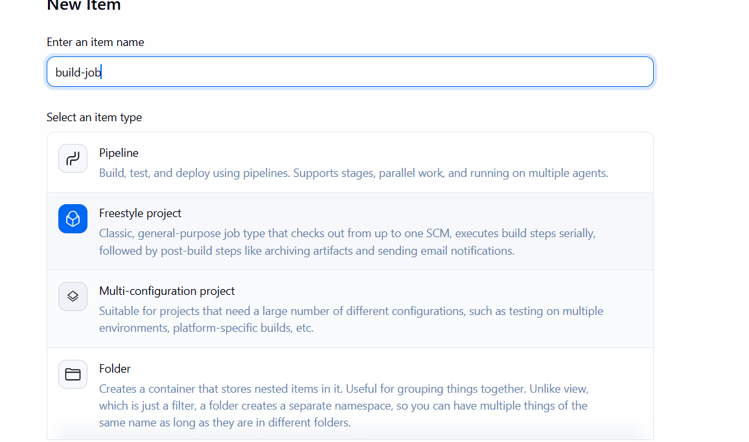

Jobs created
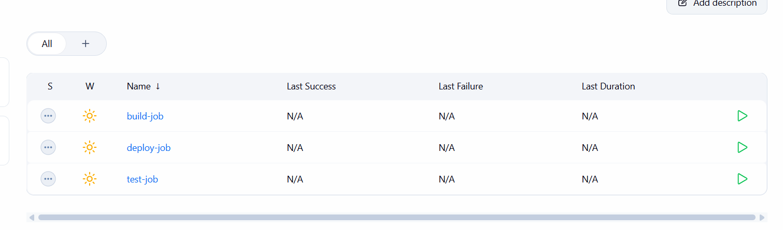

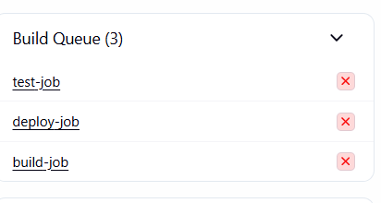

JOBS ORDERING
Process:
To implement job ordering :
i)Go inside of a job which is already created
ii)click configure and go to post build actions
iii)click add post build actions
iv)click build other projects
v)Give the name of the project and click apply and save

Order of Implementation:
When the first job is triggered then automatically all the subsequent jobs will be triggered sequentially the process of implementing jobs without starting them is called as job ordering

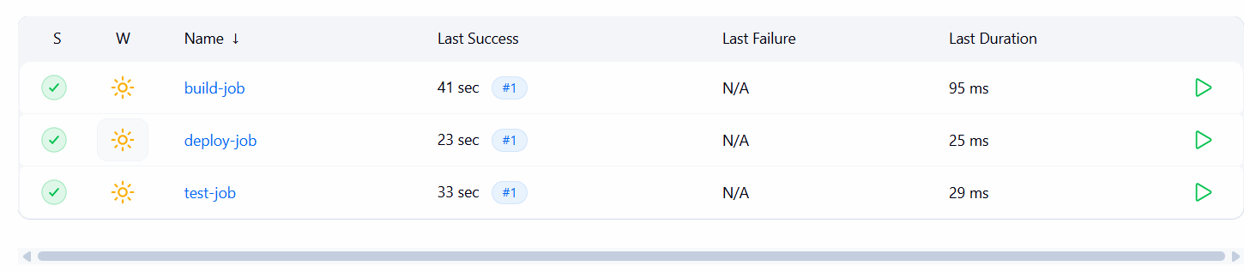
Eventhough I have clicked the build job all the following jobs are executed..
